**Launching a thread**

***What std::thread accepts in constructor ?***

We can attach a callback with the std::thread object, that will be executed when this new thread starts. These callbacks are:

1.) Function Pointer  
2.) Function Objects  
3.) Lambda functions

Thread objects can be created like this : std::thread thObj(<CALLBACK>);

void thread_function(){

for (int i = 0; i < 10000; i++);

std::cout << "thread function Executing" << std::endl;

}

std::thread threadObj(thread_function);

class DisplayThread{

public:

void operator()() {

for (int i = 0; i < 10000; i++)

std::cout << "Display Thread Executing" << std::endl;

}

};

std::thread threadObj((DisplayThread()));

std::thread threadObj([] {

for (int i = 0; i < 10000; i++)

std::cout << "Display Thread Executing" << std::endl;

});

***Start thread by member function with arguments :*** How to start a thread by a member function of class ?

class Task{

public:

void execute(std::string command); // non static member function

}

Now we want to start a thread which uses execute() function of the class Task as thread function.

As execute() is a non-static function of class Task, so first of all we need a object to call this function. Let’s create an object of class Task i.e.

Task * taskPtr = new Task();

// Create a thread using member function

std::thread th(&Task::execute, taskPtr, "Sample Task");

If execute() is static method of ***Test*** class, then syntax has little change:

// Create a thread using static member function

std::thread th(&Task::test, "Task");

***How to use std::thread as a member variable in class ?***

## ***Creating Move-only class with std::thread as member variable***

As std::thread objects are move only, therefore while designing a class that use std::thread as member variable, we need to take care that objects of this class should also be move only.

/*

* A class that has thread object as member variable

*/

class ThreadWrapper

{

// std::thread object

std::thread threadHandler;

public:

//Delete the copy constructor

ThreadWrapper(const ThreadWrapper&) = delete;

//Delete the Assignment opeartor

ThreadWrapper& operator=(const ThreadWrapper&) = delete;

// Parameterized Constructor

ThreadWrapper(std::function<void()> func);

// Move Constructor

ThreadWrapper(ThreadWrapper && obj);

//Move Assignment Operator

ThreadWrapper & operator=(ThreadWrapper && obj);

//Destructor

~ThreadWrapper();

};

Its parameterized constructor will accept callback / function pointer / function object as argument that will be used as thread function by internal thread object i.e.

//Parameterized Constructor

ThreadWrapper::ThreadWrapper(std::function<void()> func) : threadHandler(func)

{}

### **Move Constructor & Assignment Operator:** In Move constructor and assignment operator we need to move the thread object i.e.

//Move Constructor

ThreadWrapper::ThreadWrapper(ThreadWrapper && obj) : threadHandler(std::move(obj.threadHandler)){

std::cout << "Move Constructor is called" << std::endl;

}

//Move Assignment Operator

ThreadWrapper & ThreadWrapper::operator=(ThreadWrapper && obj){

std::cout << "Move Assignment is called" << std::endl;

if (threadHandler.joinable())

threadHandler.join();

threadHandler = std::move(obj.threadHandler);

return *this;

}

//Destructor

ThreadWrapper::~ThreadWrapper(){

if (threadHandler.joinable())

threadHandler.join();

}

Now Let’s create a ThreadWrapper object, now when this object will be destructed, internal thread will be joined in destructor

// Creating a std::function object

std::function<void()> func = []() {

// Sleep for 1 second

std::this_thread::sleep_for(std::chrono::seconds(1));

// Print thread ID

std::cout << "From Thread ID : " << std::this_thread::get_id() << "\n";

};

{

// Create a ThreadWrapper object

// It will internally start the thread

ThreadWrapper wrapper(func);

// When wrapper will go out of scope, its destructor will be called

// Which will internally join the member thread object

}

{

// Create a vector of ThreadWrapper objects

std::vector<ThreadWrapper> vecOfThreads;

// Add ThreadWrapper objects in thread

ThreadWrapper thwp1(func);

ThreadWrapper thwp2(func);

vecOfThreads.push_back(std::move(thwp1));

vecOfThreads.push_back(std::move(thwp2));

ThreadWrapper thwp3(func);

// Change the content of vector

vecOfThreads[1] = std::move(thwp3);

// When vector will go out of scope, its destructor will be called, which

// will internally call the destructor all ThreadWrapper objects , which in

// turn joins the member thread object.

}

**Joining and Detaching Threads**

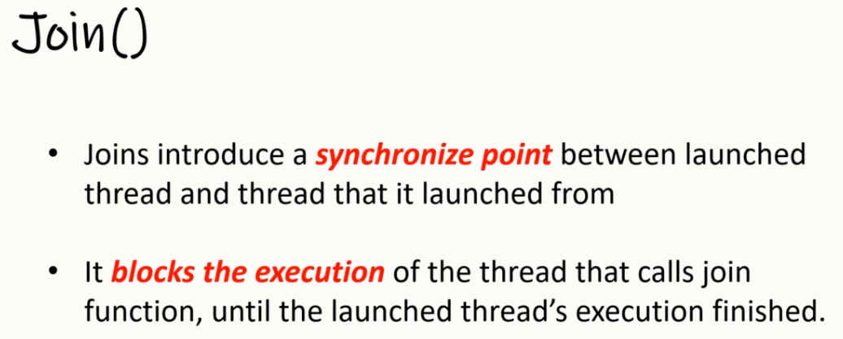Suppose Main Thread started 10 Worker Threads and after starting all these threads, main function will wait for them to finish. After joining all the threads main function will continue

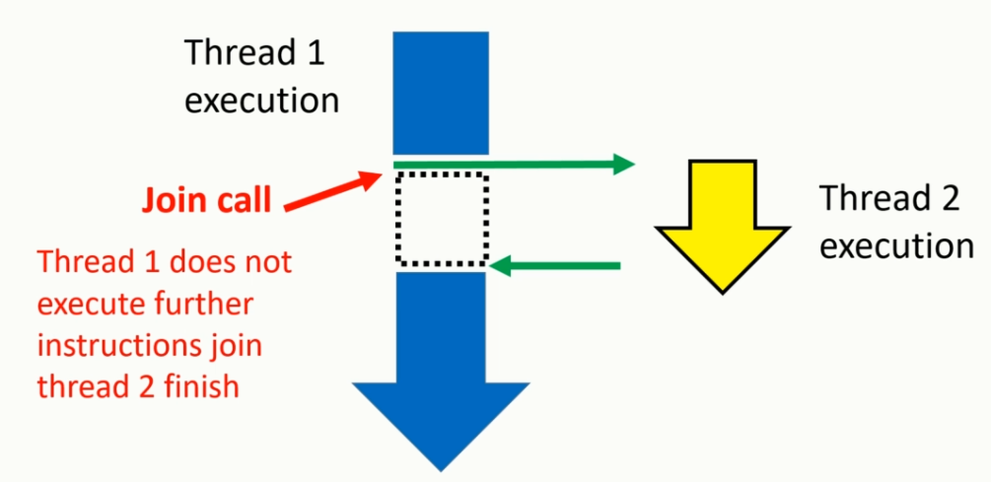

**Syntax:**

**std::thread th(funcPtr);**

**// Some Code**

**th.join();**

class WorkerThread{

public:

void operator()() {

std::cout << "Worker Thread " << std::this_thread::get_id() << " is

Executing" << std::endl;

}

};

int main(){

std::vector<std::thread> threadList;

for (int i = 0; i < 10; i++){

threadList.push_back(std::thread(WorkerThread()));

}

// Now wait for all the worker thread to finish i.e.

// Call join() function on each of the std::thread object

std::cout << "wait for all the worker thread to finish" << std::endl;

std::for_each(threadList.begin(), threadList.end(),

std::mem_fn(&std::thread::join));

std::cout << "Exiting from Main Thread" << std::endl;

}

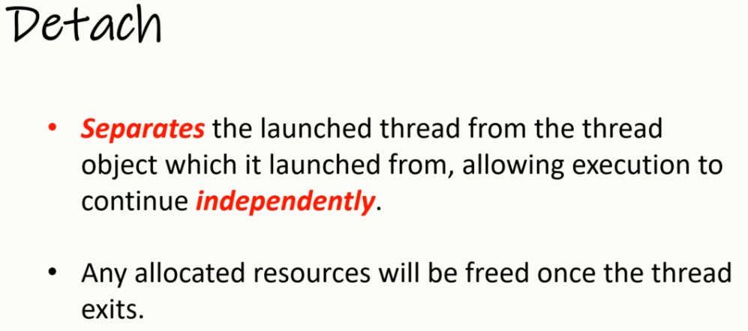

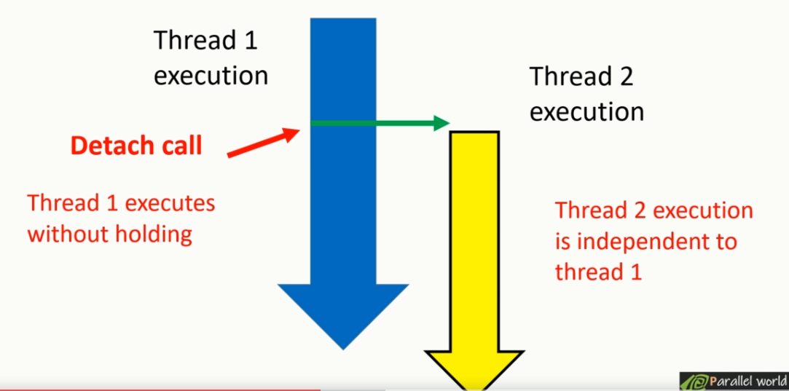

Detached threads are also called daemon / Background threads.  To detach a thread we need to call std::detach() function on std::thread object. After calling detach(), std::thread object is no longer associated with the actual thread of execution.

std::thread th(funcPtr);

th.detach();

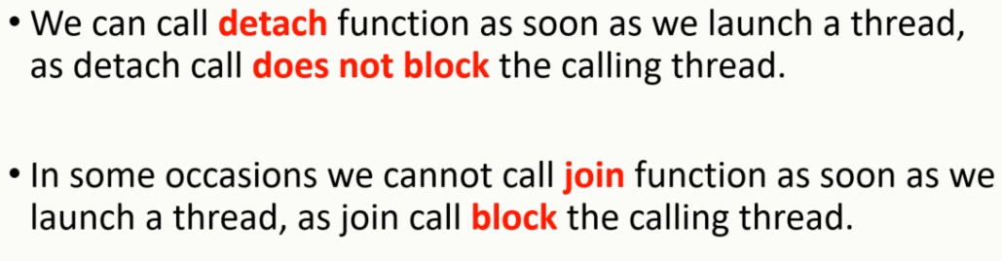

**Never call join() or detach() on std::thread object with no associated executing thread**

    std::thread threadObj( (WorkerThread()) );

    threadObj.join();

    threadObj.join(); // It will cause Program to Terminate

When a join() function is called on an thread object, std::thread object (thredObj) has no associated thread with it. In case again join() function is called on such object then it will cause the program to Terminate.

Similarly calling detach() makes the std::thread object not linked with any thread function. In that case calling detach() function twice on an std::thread object will cause the program to terminate.

So before doing join() or detach() we should check if thread is join-able every time.

If(threadObj.joinable()){

//Do join() or detach()

}

**Never forget to call either join or detach on a std::thread object with associated executing thread.**

If  neither join or detach is called with a std::thread object that has associated executing thread then during that object’s destruct-or it will terminate the program. Because inside the destruct-or it checks if Thread is Still Join-able then Terminate the program i.e.

To prevents with we should use RESOURCE ACQUISITION IS INITIALIZATION (RAII).

void foo() {

cout << "Thread method\n";

}

void otherOperation() {

cout << "Other Operation performing \n";

throw runtime_error("This is RT exception");

}

int main() {

std::thread th1(foo);

otherOperation();

th1.join(); //This will never execute.

try {

otherOperation();

th1.join();

}

catch (std::exception &e) {

th1.join(); //Join here, when exception happened.

}

}

This is also equally bad code(*code duplication th1.join()*). This kind of scenario will become difficult to manage in huge code base. Better approach is RAII.

class ThreadGuard {

std::thread &m_thread;

public:

explicit ThreadGuard(std::thread &th):m_thread(th){}

ThreadGuard& operator =(const ThreadGuard &) = delete;

ThreadGuard(const ThreadGuard&) = delete;

~ThreadGuard() {

if (m_thread.joinable())

m_thread.join();

}

};

main(){

std::thread th1(foo);

ThreadGuard tg(th1);

try {

otherOperation();

//No need to join here

}

catch (std::exception &e) {

//No need to join here }}

***Let’s see another example of custom thread wrapper class***

class ThreadManager {

public:

//Problem is, launching the thread before ThreadManager Object constructed.

ThreadManager():theThread(&ThreadManager::startThread,this),

isEnableThread(true){

cout << "Object Created\n";

}

~ThreadManager() {

isEnableThread = false;

theThread.join();

}

private:

std::thread theThread;

bool isEnableThread;

void startThread() {

while (isEnableThread)

{

cout << "Thread Enabled..\n";

std::this_thread::sleep_for(std::chrono::seconds(1));

}

}

};

void main() {

ThreadManager th1;

getchar();

}

/*

But there is a critical problem with it.

The new thread will start running as soon as it is constructed. It will not wait for the constructor to finish. It works, It may, and sometimes, at random, it will, leading you into a false sense of security and correctness.

It will not even wait for other class fields to be constructed. It has the right to cause crash when accessing stop_thread. And what if your class has other fields that are not atomic? The thread can start using uninitialized

objects, problems guaranteed.

One possible solution would be to have the constructor notify the thread when it is safe to start, from within its body. This might be accomplished with an atomic or with a conditional variable. Keep in mind that it would need to be constructed

before the std::thread, so that it is ready to use when the thread starts (so the order of construction really does matter!).

This might work in case of the code I use for demonstration. But in general case this will do no good. Imagine use a hierarchy of polymorphic thread-managing classes; imagine that startThread is virtual. In such scenario its addresses

is derived from the vtable. But the vtable pointer is initialized after the block of the constructor! This means the starting thread would start from calling a wrong function, leading to a variety of confusing behaviour. The idea of

notifying it when to start won’t help here.

A universal solution would be to prepare then class in two steps.

* First, construct it.

* When it is ready to use, call Start() which will actually launch the thread.

Like this:

ThraedManager instance;

instance.Start();

*/

class ThreadManager {

public:

ThreadManager() : isReady(true) {}

~ThreadManager() {

isReady = false;

if(theThread->joinable())

theThread->join();

}

void startThread() {

theThread = new std::thread(&ThreadManager::doJob, this);

}

private:

std::thread *theThread;

bool isReady;

void doJob() {

while (isReady){

cout << "Thraed Enabled..\n";

std::this_thread::sleep_for(std::chrono::seconds(1));

}

}

};

int main(){

ThreadManager th;

th.startThread();

getchar();

return 0;

}

***Simple example of thread dispatcher***

inline int randrange(int lo, int hi){

return rand() / (RAND_MAX / (hi - lo + 1)) + lo;

}

std::mutex mtx;

class Thread {

public:

thread::id pid() const { return m_pid; }

~Thread() {

running = false;

if (theThread->joinable())

theThread->join();

}

void startThread() {

// Don't start two threads on the same object

if (running) return;

// Create an CPP thread, using the static callback

theThread = new std::thread(&Thread::dispatch, this);

running = 1;

}

protected:

Thread() : running(0) {}

virtual void code() = 0;

private:

std::thread *theThread;

bool running;

static thread::id m_pid;

static void dispatch(void* thread_obj) {

m_pid = this_thread::get_id();

((Thread*)thread_obj)->code(); // Call the actual OO thread code

delete (Thread*)thread_obj; // After code() returns, kill the

// thread object

}

};

thread::id Thread::m_pid;

///////////////////////////////////////////////////////////////////////

// An example thread class

///////////////////////////////////////////////////////////////////////

class Dice : public Thread {

public:

static void Dice::create(const char* dicename) {

(new Dice(dicename))->startThread();

}

~Dice() {

std::cout << name.c_str() << " :: Dies\n";

}

private:

Dice(const char* dicename) : name(dicename) {}

virtual void code();

std::string name;

};

void Dice::code(){

std::unique_lock<std::mutex> locker(mtx);

std::cout << "Started thread #" << pid() << " for " << name.c_str() <<”\n”;

locker.unlock();

srand(time(0));

for (;;) {

int val = randrange(1, 6);

locker.lock();

std::cout << name.c_str() << " rolled " << val << std::endl;

locker.unlock();

// wait up to 500 ms

this_thread::sleep_for(chrono::milliseconds(randrange(100, 500)));

}

}

///////////////////////////////////////////////////////////////////////

// Let's test!

///////////////////////////////////////////////////////////////////////

int main()

{

{

Dice::create("dice1");

Dice::create("dice2");

this_thread::sleep_for(chrono::seconds(5)); // roll dice for 5 seconds

}

return 0; // cleanup? what's cleanup?

}

# **Carefully Pass Arguments to Threads**

To Pass arguments to thread’s associated callable object or function just pass additional arguments to the std::thread constructor. By default, all arguments are copied into the internal storage of new thread.

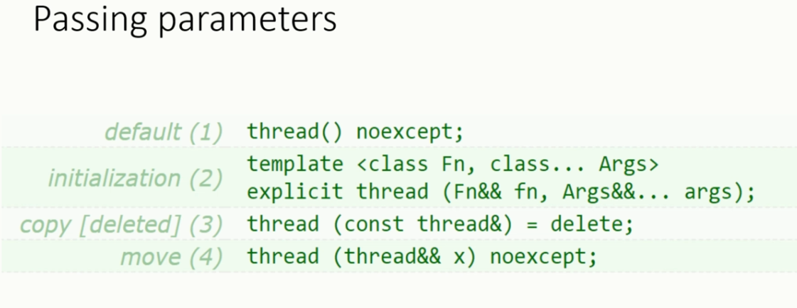

void threadCallback(int x, std::string str){

std::cout << "Passed Number = " << x << std::endl;

std::cout << "Passed String = " << str << std::endl;

}

int main(){

int x = 10;

std::string str = "Sample String";

std::thread threadObj(threadCallback, x, str);

threadObj.join();

}

## *How not to pass arguments to threads in C++11*

Don’t pass addresses of variables from local stack to thread’s callback function. Because it might be possible that local variable in Thread 1 goes out of scope, but Thread 2 is still trying to access it through its address. In such scenario accessing invalid address can cause unexpected behavior.

void newThreadCallback(int * p){

std::cout << "Inside Thread : "" : p = " << p << std::endl;

std::this_thread::sleep_for(chrono::millisecond(2000));

*p = 19;

}

void startNewThread(){

int i = 10;

std::cout << "Inside Main Thread : "" : i = " << i << std::endl;

std::thread t(newThreadCallback, &i);

t.detach();

std::cout << "Inside Main Thread : "" : i = " << i << std::endl;

}

int main()

{

startNewThread();

std::this_thread::sleep_for(chrono::millisecond(2000));

return 0;

}

Similarly, be careful while passing pointer to memory located on heap to thread. Because it might be possible that some thread deletes that memory before new thread tries to access it. In such scenario accessing invalid address can cause unexpected behavior.

void startNewThread(){

int *i = new int(10);

std::cout << "Inside Main Thread : "" : i = " << i << std::endl;

std::thread t(newThreadCallback, i);

t.detach();

delete I;

}

**Another Example is**

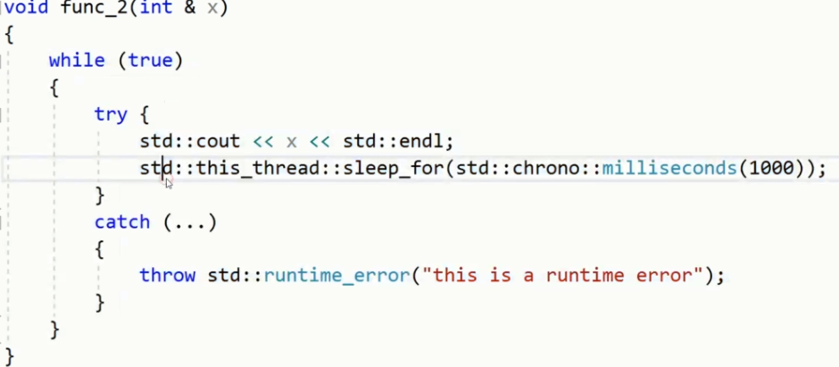

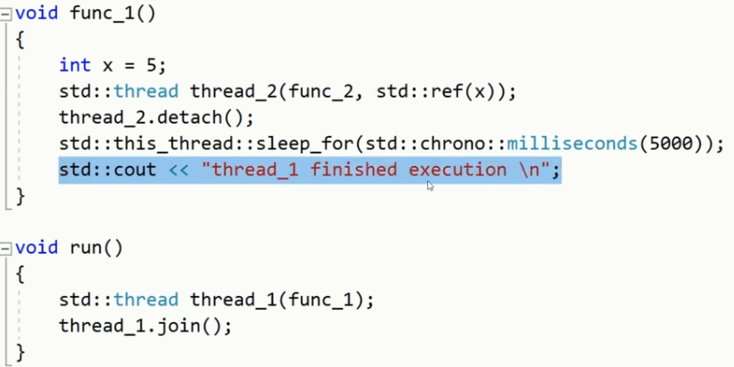

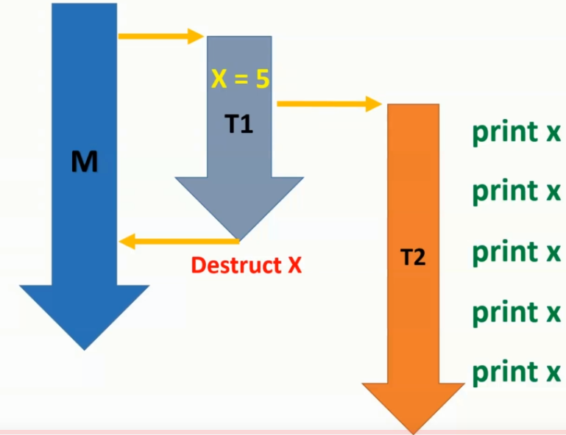

## *How to pass references to std::thread in C++11*

void threadCallback(int const & x){

int & y = const_cast<int &>(x);

y++;

std::cout << "Inside Thread x = " << x << std::endl;

}

int main(){

int x = 9;

std::cout << "In Main Thread : Before Thread Start x = " << x << std::endl;

std::thread threadObj(threadCallback, x);

threadObj.join();

std::cout << "In Main Thread : After Thread Joins x = " << x << std::endl;

return 0;

}

**O/P is:**

*In Main Thread : Before Thread Start x = 9*  
*Inside Thread x = 10*  
*In Main Thread : After Thread Joins x = 9*

Even if threadCallback accepts arguments as reference but still changes done it are not visible outside the thread. It’s because x in the thread function threadCallback is reference to the temporary value copied at the new thread’s stack.

How to fix this ? ***Using std::ref()***

std::thread threadObj(threadCallback,std::ref(x));

## *Assigning pointer to member function of a class as thread function:*

Pass the pointer to member function as callback function and pass pointer to Object as second argument.

class DummyClass {

public:

DummyClass() {}

DummyClass(const DummyClass & obj) {}

void sampleMemberFunction(int x){

std::cout << "Inside sampleMemberFunction " << x << std::endl;

}

};

int main() {

DummyClass dummyObj;

int x = 10;

std::thread threadObj(&DummyClass::sampleMemberFunction, &dummyObj, x);

threadObj.join();

}

# **Transferring ownership of the thread**

We Can transfer the ownership by using move constructor of thread class.



void foo() {

cout << "Thread method foo\n";

}

void bar() {

cout << "Thread method foo\n";

}

thread th1(foo);

//thread th2=th1 //Error

thread th2 = move(th1); //fine

th2.join() //th1.join() gives error.

Below line, we have temporary object in right side of this assignment operator,

not name variable as in previous case. In this type of situations, implicit move call happens.

thread th3 = std::thread(foo);

Let’s suppose th1 has owning one thread.

thread th1(foo);

th1 = thread(bar);

//OR, thread th2(bar); th1 = move(th2);

th1.join();

In such case It throw runtime error. On LHS side thread object should not own any object.

**Parallel accumulate Example:**

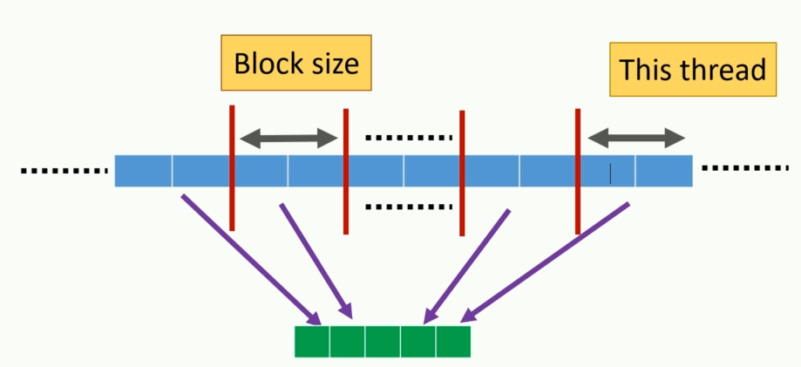

std::mutex mu;

template<typename iterator, typename T>

void accumulate_block(iterator start, iterator end, T& result){

mu.lock();

result = std::accumulate(start, end, result);

std::cout << "Thread_ID ::"<< std::this_thread::get_id() << "->" << result;

mu.unlock();

}

template<typename iterator, typename T>

T accumulate_list(iterator start, iterator end, T init)

{

//get size of the input list

int distance = std::distance(start, end);

if (!distance) {

return init;

}

//we set minimum number of threads to run in each thread

const int min_elements = 500;

//max threads depend on min elements for each threads

int max_threads = distance / min_elements;

std::cout << "Max number of threads to run to avoid heavy overload -" <<

max_threads << std::endl;

// max threads hardware allowed to run concurrently

int allowed_thread = std::thread::hardware_concurrency();

std::cout << "Max number of threads to run to avoid oversubscription -" <<

allowed_thread << std::endl;

// get the minimum of above two values, to avoid both oversubscription and

heavy overload

int runing_threads = std::min(allowed_thread > 0 ? allowed_thread : 2,

max_threads);

std::cout << "Runing threads -" << runing_threads << std::endl;

// reduced result list, this is were we store result of each block

std::vector<T> results(runing_threads);

// vector to store number of threads

std::vector<std::thread> threads(runing_threads - 1);

iterator block_start = start;

// decide block size based on number of runing thread

int block_size = distance / (runing_threads);

//send perticular block of data to separate thread to accumulate

for (int i = 0; i < (runing_threads - 1); i++){

iterator block_end = block_start;

std::advance(block_end, block_size);

threads[i] = std::thread(accumulate_block<iterator, T>, block_start,

block_end, std::ref(results[i]));

block_start = block_end;

}

//accumulate last block in this thread

accumulate_block<iterator, T>(block_start,

end, results[runing_threads - 1]);

std::for_each(threads.begin(), threads.end(),

std::mem_fn(&std::thread::join));

return std::accumulate(results.begin(), results.end(), init);

}

int main()

{

int number_of_elements = 5000;

std::vector<int> values(number_of_elements);

for (int i = 0; i < number_of_elements; i++)

values[i] = i;

int val = 0;

long addition = accumulate_list(values.begin(), values.end(), val);

std::cout << "Summation of list -" << addition << std::endl;

system("pause");

return 0;

}

**When using mutex need to consider below things:**

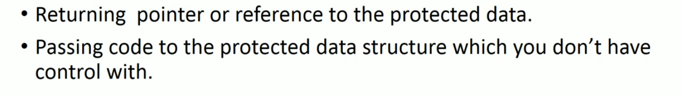

class list_wrapper{

std::list<int> my_list;

std::mutex m;

public :

void add_to_list(int const & x) {

std::lock_guard<std::mutex> lg(m);

my_list.push_front(x);

}

void size(){

std::lock_guard<std::mutex> lg(m);

int size = my_list.size();

std::cout << "size of the list is : " << size << std::endl;

}

std::list<int>* get_data(){

return &my_list; //returning the pointer of protected data.

}

};

class data_object{

public:

void some_operation() {

std::cout << "this is some operation \n";

}

};

class data_wrapper{

data_object protected_data;

std::mutex m;

public:

template <typename function>

void do_some_work(function f){

std::lock_guard<std::mutex> lg(m);

f(protected_data);

}

};

data_object* unprotected_data;

void malisious_function(data_object& data){

unprotected_data = &data;

}

int main(){

data_wrapper wrapper;

wrapper.do_some_work(malisious_function);

system("pause");

return 0;

}

**Thread safe stack implementation:**

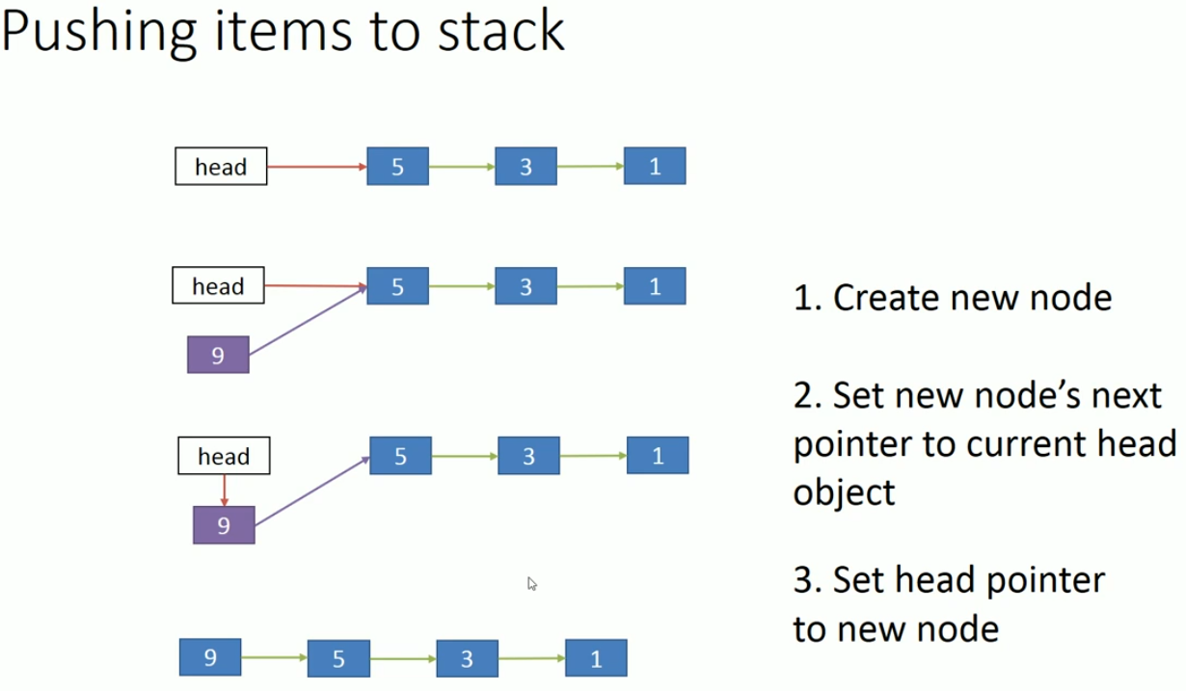

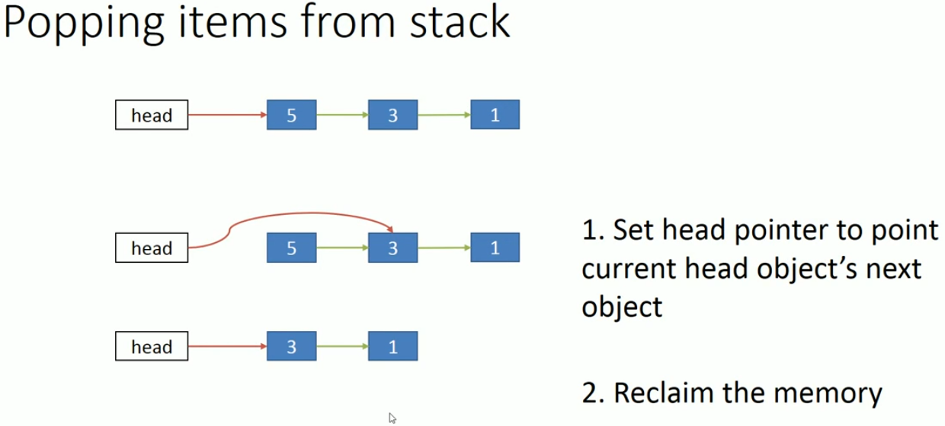

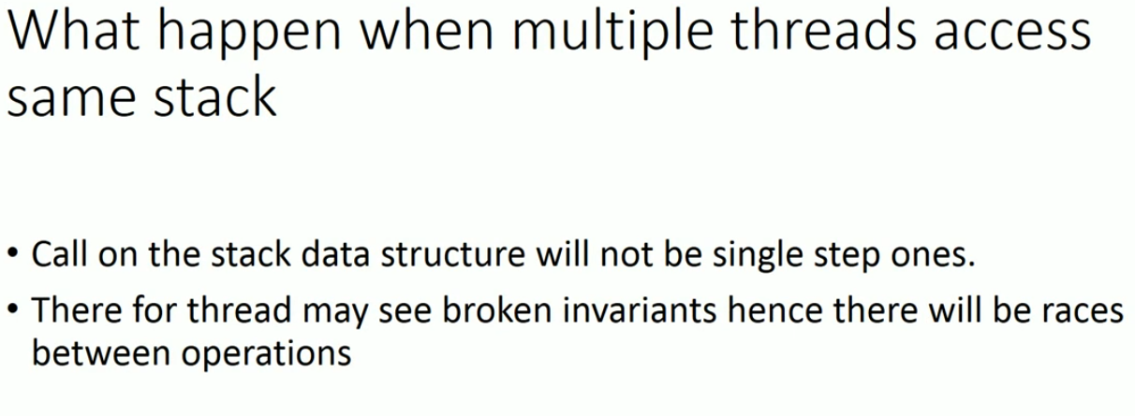

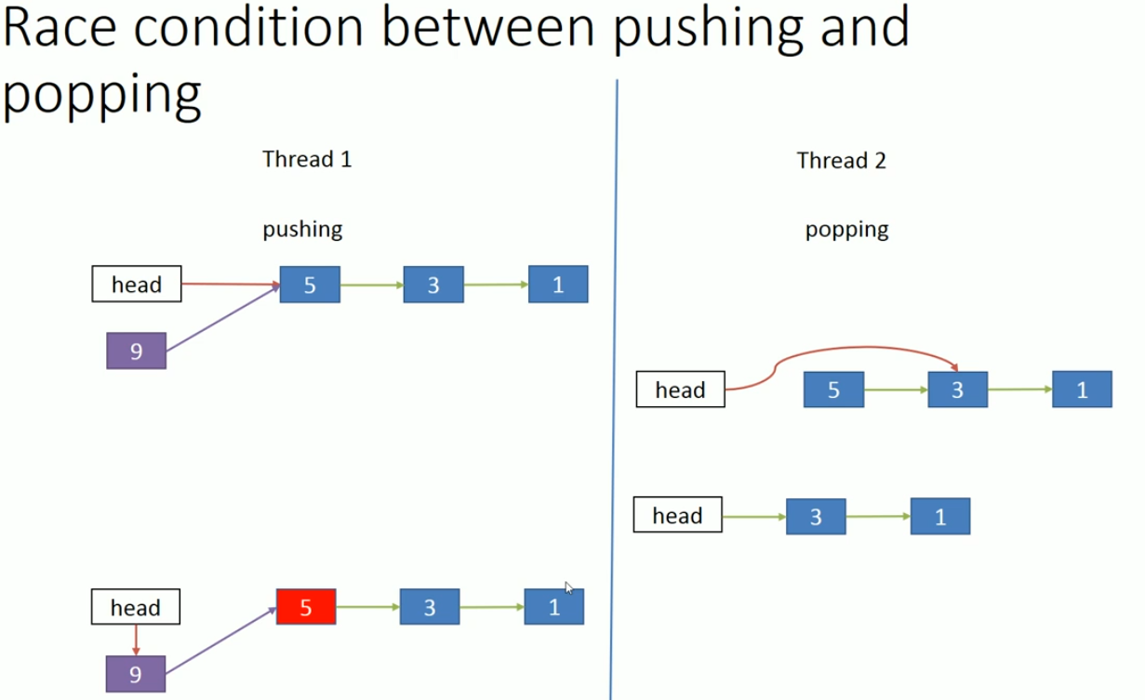

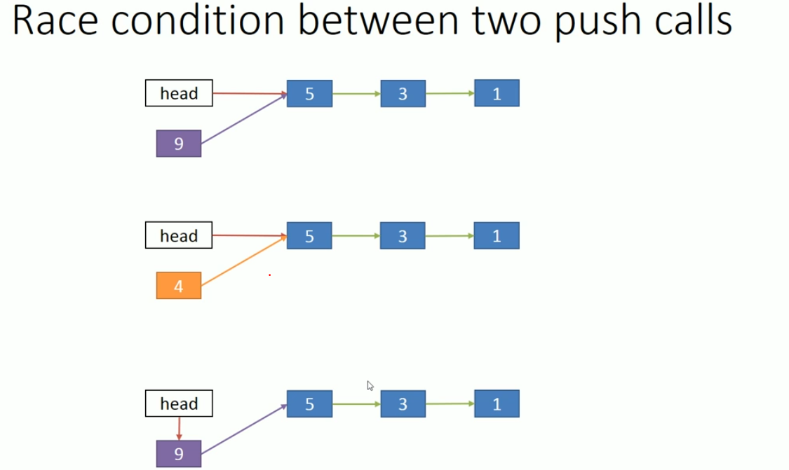

**Race Condition:**

In multithreading environment data sharing between threads is very easy. But this easy sharing of data can cause problems in application. One such problem is Race Condition.

## **What is a Race Condition?**

Race condition is a kind of a bug that occurs in multithreaded applications.

When two or more threads perform a set of operations in parallel, that access the same memory location.  Also, one or more thread out of them modifies the data in that memory location, then this can lead to an unexpected result sometimes.

Race conditions are usually hard to find and reproduce because they don’t occur every time. They will occur only when relative order of execution of operations by two or more threads leads to an unexpected result.

## How to fix Race Conditions?

To fix this problem we need to use Lock mechanism i.e. each thread needs to acquire a lock before modifying or reading the shared data and after modifying the data each thread should unlock the lock.

1. Use mutex to synchronize data access.
2. Never leak handle of data to outside.
3. Design interface appropriately.

**Simple stack implementation:**

template<typename T>

class trivial_thread_safe_stack{

std::stack<T> stk;

std::mutex m;

public:

void push(T element) {

std::lock_guard<std::mutex> lg(m);

stk.push(element);

}

void pop(){

std::lock_guard<std::mutex> lg(m);

stk.pop();

}

T& top(){

std::lock_guard<std::mutex> lg(m);

return stk.top();

}

bool empty(){

std::lock_guard<std::mutex> lg(m);

return stk.empty();

}

size_t size() {

std::lock_guard<std::mutex> lg(m);

return stk.size();

}

};

trivial_thread_safe_stack<int> stk;

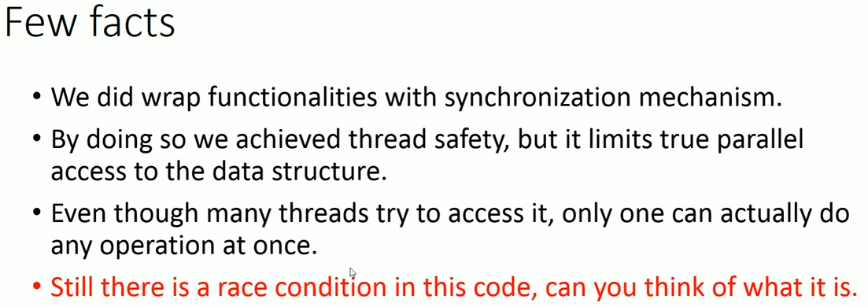

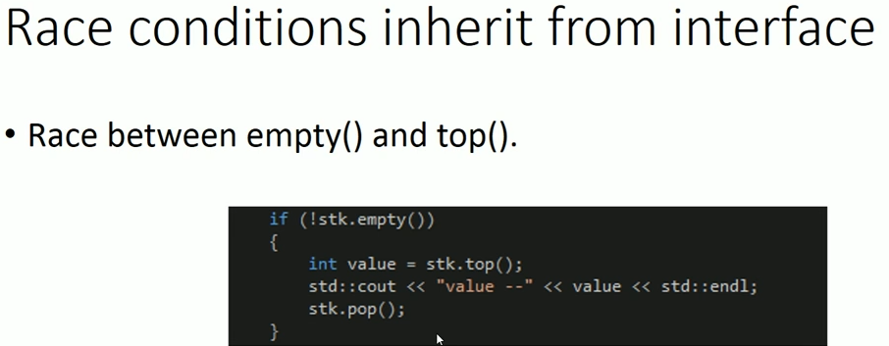

*Just think about the invoking top() method on empty stack (Lead to crash).*

Let’s suppose thread1 check stack empty or not, found only one object inside the stack and enter inside if block. Now before getting called top context switch occurred, and another thread2 remove the content of stack (perform pop). After that thread1 resume its execution and perform top() which lead program crash.



Another loophole in this interface, Suppose stack is protected by a mutex internally, only one thread can be running a stack member function at any one time, so the calls get nicely interleaved, while the calls to do_something() can run concurrently. Find the below flow:

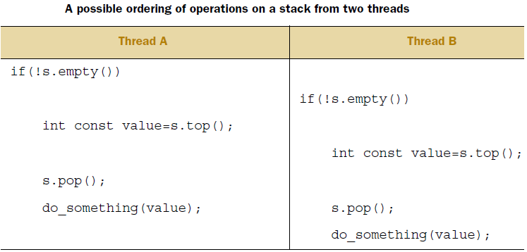

Suppose Stack contains two value {3,5}. Thread A value=5 and Thread B value=5; good so far. Now pop() called by Thread A, 5 is popped out, again Thread B called pop() and now 3 is popped out.

Consequently, one of the two values on the stack is discarded without ever having been read, whereas the other is processed twice. This is yet another race condition and far more insidious than previous one.

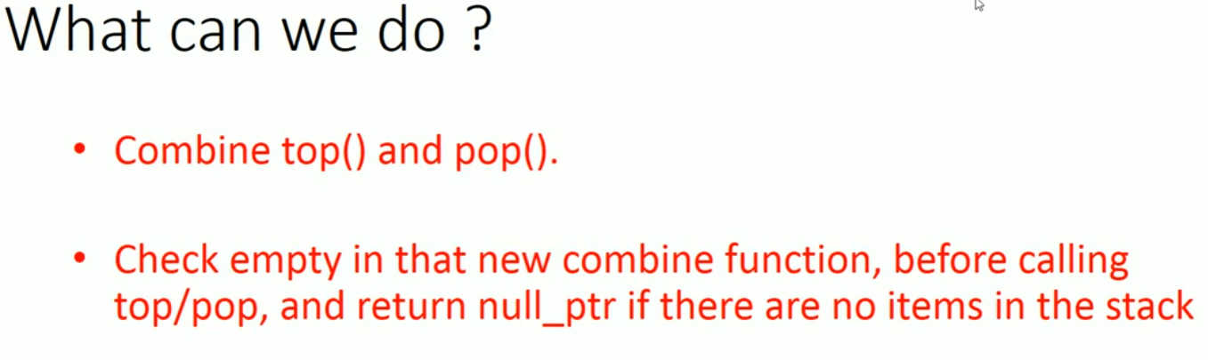

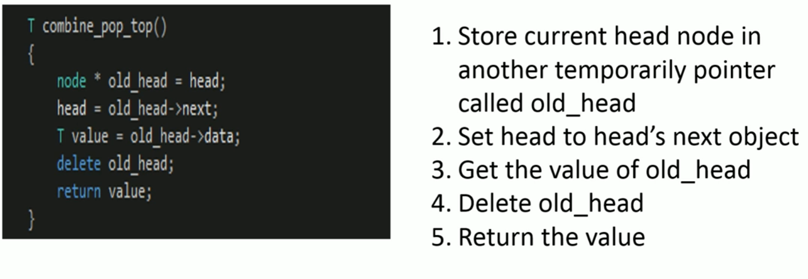

Still having problem with above code. Returning by value would required copy constructor call to allocate the memory. Let suppose memory allocation failed meanwhile we already deleted our ***old_head,*** then our program will become inconsistent.

**Let’s move to healthy interface design:**

The first option is to pass a reference to a variable which receive the popped value as an argument in the call to pop():

Stack<Widget> wstack;

Widget someWidget;

wstack.pop(someWidget); //It is better, if Widget class support move construct.

**Implements another version of pop() like below:**

Std::shared_ptr<T> pop(); //But why?

Suppose this time stack of widget* : Stack<Widget*> wstack; and our pop call:

Widget *someWidget;

wstack.pop(someWidget);

What will happened if we delete the someWidget or update the value of someWidget?

In both case the shared_ptr will take care of situation. *(delete only decrease the refcnt and update in value will create new widget).*

template<typename T>

class thread_safe_stack{

std::stack<std::shared_ptr<T>> stk;

std::mutex m;

public:

void push(T element){

std::lock_guard<std::mutex> lg(m);

stk.push(std::make_shared<T>(element));

}

std::shared_ptr<T> pop(){ //Pop & top together, One way

std::lock_guard<std::mutex> lg(m);

if (stk.empty()) {

throw std::runtime_error("stack is empty");

}

std::shared_ptr<T>res(stk.top()); //getting shared pointer form stk

stk.pop();

return res;

}

void pop(T& value){ //Pop & top together, another way

std::lock_guard<std::mutex> lg(m);

if (stk.empty()) //Avoid race condition between pop &empty

throw std::runtime_error("stack is empty");

value = *(stk.top().get());//get value from shared pointer.

stk.pop();

}

bool empty(){

std::lock_guard<std::mutex> lg(m);

return stk.empty();

}

size_t size(){

std::lock_guard<std::mutex> lg(m);

return stk.size();

}

};

thread_safe_stack<int> stk;

void func_1(){

if (!stk.empty()){

//int value = *(stk.pop().get());

int value;

stk.pop(value);

std::cout << "value --" << value << std::endl;

}

else{

std::cout << "stack is empty \n";

}

}

int main(){

stk.push(1);

stk.push(2);

std::thread thread_1(func_1);

std::thread thread_2(func_1);

thread_1.join();

thread_2.join();

if (stk.empty()) {

std::cout << "stack is now empty \n";

}

system("pause");

return 0;

}

Considered the points in above interface design:

* The pop() functions throw an empty_stack exception if the stack is empty, so everything still works even if the stack is modified after a call to empty().
* std::shared_ptr allows the stack to take care of the memory-allocation issues and avoid excessive calls to new and delete if desired (by using refCnt mechanism).
* Actual top() and pop() internally wrapped into single interface.

**Deadlock:**

This is a situation about cyclic wait where one thread1 acquire resource r1 and waiting for r2 which is already acquire by thread2. And thread2 asking about r1 which held by thread1. It creates infinite waiting.

std::mutex m1;

std::mutex m2;

void m1_frist_m2_second(){

std::lock_guard<std::mutex> lg1(m1);

std::this_thread::sleep_for(std::chrono::milliseconds(1000));

std::cout << "thread " << std::this_thread::get_id() <<

" has acquired lock for m1 mutex, its wait for m2 \n";

std::lock_guard<std::mutex>lg2(m2);

std::cout << "thread " << std::this_thread::get_id() <<

" has acquired lock for m2 mutex \n";

}

void m2_frist_m1_second(){

std::lock_guard<std::mutex> lg1(m2);

std::this_thread::sleep_for(std::chrono::milliseconds(1500));

std::cout << "thread " << std::this_thread::get_id() <<

" has acquired lock for m2 mutex, its wait for m1 \n";

std::lock_guard<std::mutex>lg2(m1);

std::cout << "thread " << std::this_thread::get_id() <<

" has acquired lock for m1 mutex \n";

}

int main(){

std::thread thread_1(m1_frist_m2_second);

std::thread thread_2(m2_frist_m1_second);

thread_1.join();

thread_2.join();

}

class bank_account{

double balance;

std::string name;

std::mutex m;

public:

bank_account(){};

bank_account(double _balance, std::string _name) :

balance(_balance), name(_name){}

bank_account(bank_account& const) = delete;

bank_account& operator=(bank_account& const) = delete;

void withdraw(double amount){

std::lock_guard<std::mutex> lg(m);

balance += amount;

}

void deposite(double amount){

std::lock_guard<std::mutex> lg(m);

balance += amount;

}

void transfer(bank_account& from, bank_account& to, double amount){

std::lock_guard<std::mutex> lg_1(from.m);

std::cout << "lock for " << from.name << " account acquire by " <<

std::this_thread::get_id() << std::endl;

std::this_thread::sleep_for(std::chrono::milliseconds(1000));

std::cout << "waiting to acquire lock for " << to.name << "account by” << std::this_thread::get_id() << std::endl;

std::lock_guard<std::mutex> lg_2(to.m);

from.balance -= amount;

to.balance += amount;

std::cout << "transfer to - " << to.name << " from - " << from.name

<< " end \n";

}

};

int main(){

bank_account account;

bank_account account_1(1000, "james");

bank_account account_2(2000, "Mathew");

std::thread thread_1(&bank_account::transfer, &account, std::ref(account_1),

std::ref(account_2), 500);

std::this_thread::sleep_for(std::chrono::milliseconds(100));

std::thread thread_2(&bank_account::transfer, &account, std::ref(account_2),

std::ref(account_1), 200);

thread_1.join();

thread_2.join();

}

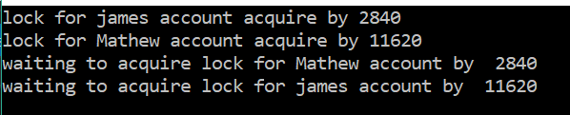

**Another classic example of deadlock is:**

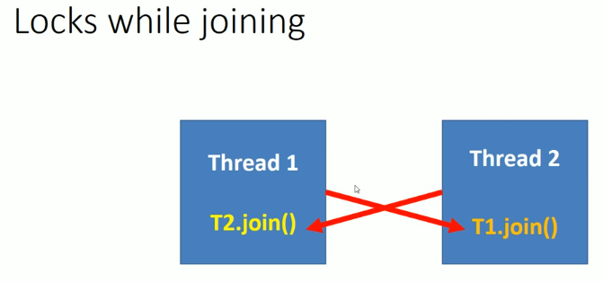

To avoid the deadlock, make sure everybody acquires mutex in same order. In

C++ Standard library have some function which provide deblock avoidance algorithm.

**Lock()** function, lock any number of mutex and have deadlock avoidance algorithms.

One possible solution of above example is below:

void transfer(bank_account& from, bank_account& to, double amount){

std::lock(from.m, to.m);

std::cout << std::this_thread::get_id()<<" hold the lock for both mutex \n";

std::lock_guard<std::mutex> lg_1(from.m, std::adopt_lock);

std::lock_guard<std::mutex> lg_2(to.m, std::adopt_lock);

from.balance -= amount;

to.balance += amount;

std::cout << "transfer to - " << to.name << " from - " << from.name << "

successful \n";

}

**Avoiding deadlock:**

1. Prefers locking single mutex.
2. Avoid locking a mutex and then calling a user provided function.
3. Use std::lock() to lock more than one mutex.
4. Lock mutex in same order.

**Unique_lock and lazy initialization:**

Unique_lock is similar to lock_guard but provide more functionality.

void fun() {

std::unique_lock<std::mutex> locker(mu);

/* cretical section*/

locker.unlock();

/*non-cretical section*/

//Again can lock the mutex for another critical section.

locker.lock();

}

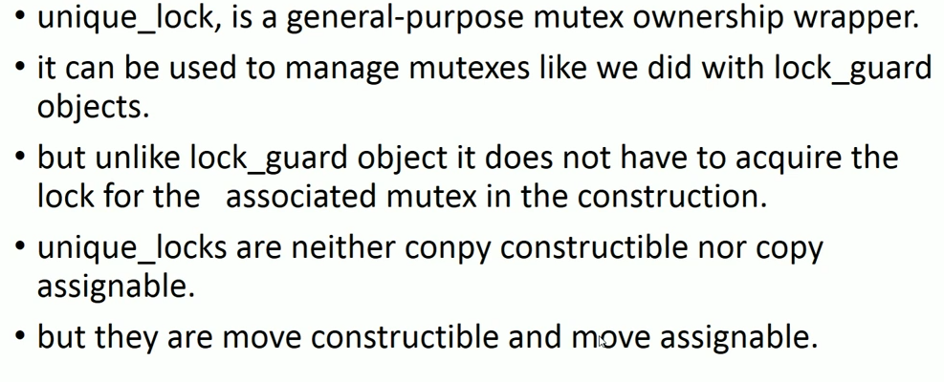

By using unique_lock() we can even construct the locker without locking it.

void fun() {

std::unique_lock<std::mutex> locker(mu,std::defer_lock);

//Argument std::defer_lock not locking mutex instantly.

locker.lock();

/* cretical section starts*/

locker.unlock();

/*non-cretical section*/

//Again can lock the mutex for another critical section.

locker.lock();

//RAII approch, mutex got relese when locker went out of scope.

}

void transfer(bank_account& from, bank_account& to, double amount){

std::cout << std::this_thread::get_id()<<"hold the lock for both mutex \n";

std::unique_lock<std::mutex> ul_1(from.m, std::defer_lock);

std::unique_lock<std::mutex> ul_2(to.m, std::defer_lock);

std::lock(ul_1, ul_2);

from.balance -= amount;

to.balance += amount;

std::cout << "transfer to - " << to.name << " from - " << from.name <<”\n”

}

*Note: A wrapper class lock_gaurd aand unique_lock never copied. But unique_lock*

*Provide flexibility to move ownership control using move() function.*

unique_lock<std::mutex> loker1(mu);

unique_lock<std::mutex> loker2 = std::move(locker1);

*Another example of move semantic supported by unique_lock*

void x_operations(){

std::cout << "this is some operations \n";

}

void y_operations(){

std::cout << "this is some other operations \n";

}

std::unique_lock<std::mutex> get_lock(){

std::mutex m;

std::unique_lock<std::mutex> lk(m);

x_operations();

return lk;

}

int main(){

//move semantic is used to construct the lock object which is returned by

//get_lock() method. Here the same mutex is used to perform x and y

//operation.

std::unique_lock<std::mutex> lk(get_lock());

y_operations();

system("pause");

return 0;

}

**Synchronization & Communication between thread using condition variables and futures**

***Need of Event Handling:***

Sometimes a thread needs to wait for an event to happen like a condition to become true or a task to be completed by another thread.

For example, suppose we are building a network-based application. This application does following tasks:

1. Perform some handshaking with server
2. Load Data from XML files.
3. Do processing on data loaded from XML.

As we can see that Task 1 is not dependent on any other Tasks, but Task 3 is dependent on Task 2. So, it means Task 1 and Task 2 can be run in parallel by different Threads to improve the performance of application.

So, let’s break this into a multi-threaded application, now it includes two threads, Responsibilities of Thread 1 are:

* Perform some handshaking with server.
* Wait for data to be loaded from XML by Thread 2
* Do processing on data loaded from XML.

Responsibilities of Thread 2 are:

* Load data from XML
* Notify another Thread i.e. waiting for the message.

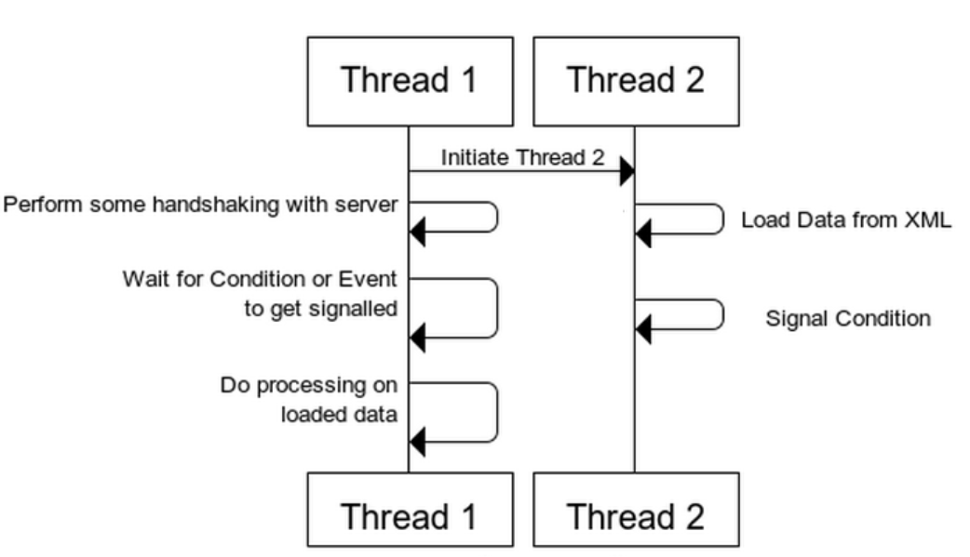

In above, Thread 1 performs some operations and then waits for an event/condition to happen. The event or condition here is, *Is Data loaded successfully?*

Once Thread 1 receives that Event then it performs some processing on the data. Thread 2 loads the data in parallel when Thread 1 was busy in doing Handshake Mechanism.

When Thread 2 successfully loads the data from XML, it then notifies the Thread 1 by signalling that Event. Now When Event or Condition is signalled then Thread 1 will continue the processing of Data.

What’s the benefit of making it multi-threaded?

When Thread 1 is busy in some handshaking mechanism then Thread 2 will load the data parallel from XML. So, it will increase the performance of application.

Now, how to achieve this,

**Option 1:**

Make a Boolean global variable with default value false. Set its value to true in Thread 2 and Thread 1 will keep on checking its value in loop and as soon as it becomes true Thread 1 will continue with processing of data. But as it’s a global variable shared by both threads it needs synchronization with mutex. Let’s see its code,

class Application

{

std::mutex m_mutex;

bool m_bDataLoaded;

public:

Application():m_bDataLoaded(false){};

void loadData() {

// Make This Thread sleep for 1 Second

std::this_thread::sleep_for(std::chrono::milliseconds(1000));

std::cout << "Loading Data from XML" << std::endl;

// Lock The Data structure

std::lock_guard<std::mutex> guard(m_mutex);

// Set the flag to true, means data is loaded

m_bDataLoaded = true;

}

void mainTask(){

std::cout << "Do Some Handshaking" << std::endl;

// Acquire the Lock

m_mutex.lock();

// Check if flag is set to true or not

while (m_bDataLoaded != true){

// Release the lock

m_mutex.unlock();

//sleep for 100 milli seconds

std::this_thread::sleep_for(std::chrono::milliseconds(100));

// Acquire the lock

m_mutex.lock();

}

// Release the lock

m_mutex.unlock();

//Doc processing on loaded Data

std::cout << "Do Processing On loaded Data" << std::endl;

}

};

int main(){

Application app;

std::thread thread_1(&Application::mainTask, &app);

std::thread thread_2(&Application::loadData, &app);

thread_2.join();

thread_1.join();

}

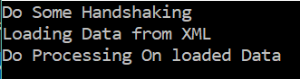

**It has following disadvantages:**

Thread will keep on acquiring the lock and release it just to check the value, therefore it will consume CPU cycles and will also make Thread 1 slow, because it needs to acquire same lock to update the bool flag.

So obviously we need a better mechanism to achieve this, like if somehow Thread 1 could just block by waiting for an Event to get signalled and another Thread could signal that Event and make Thread 1 continue. It would have saved many CPU cycles and gave better performance. But the question is how to achieve this?

**Option 2:**

We can achieve this using *Condition Variables.* It is a kind Event used for signaling between 2 threads. One thread can wait for it to get signaled, while other thread can signal this.

Condition Variable is a kind of Event used for signaling between two or more threads. One or more thread can wait on it to get signaled, while another thread can signal this.

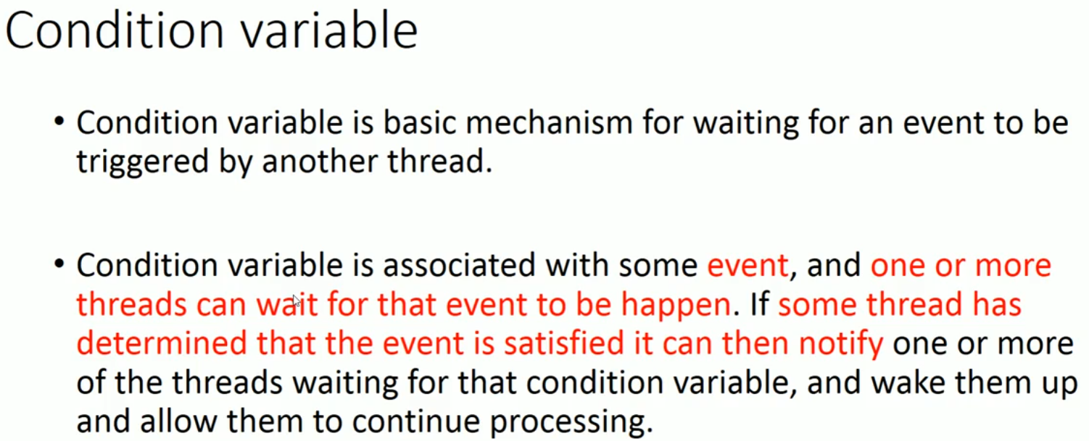

A mutex is required along with condition variable.

**How things work with condition variable:**

* Thread 1 calls the wait on condition variable, which internally acquires the mutex and check if required condition is met or not.
* If not then it releases the lock and waits for Condition Variable to get signalled ( thread gets blocked). Condition Variable’s wait() function provides both these operations in atomic manner.
* Another Thread i.e. like Thread 2 signals the Condition Variable when condition is met
* Once Conditional Variable get signalled the Thread 1 which was waiting for it resumes. It then acquires the mutex lock again and checks if the condition associated with Condition Variable is met or if it is superiors call. If more than one thread was waiting, then notify_one will unblock only one thread.
* If it was a superiors call then it again calls the wait() function.

**Main member functions for std::condition_variable are:**

**Wait() :** It makes the current thread to block until the condition variable get signalled or a spurious wake up happens. It atomically releases the attached mutex, blocks the current thread, and adds it to the list of threads waiting on the current condition variable object.

The thread will be unblocked when some thread calls notify_one() or notify_all() on same condition variable object. It may also be unblocked spuriously, therefore after every unblocking it needs to check condition again.

A callback is passed as a parameter to this function, which will be called to check if it is a spurious call or condition is met.

When threads get unlocked, wait() function reacquires the mutex lock and checks that actually condition is met or not. If condition is not met then again it atomically releases the attached mutex, blocks the current thread, and adds it to the list of threads waiting on the current condition variable object.

**notify_one()**

If any threads are waiting on same conditional variable object then  notify_one unblocks one of the waiting threads.

**notify_all()**

If any threads are waiting on same conditional variable object then  notify_all unblocks all of the waiting threads.

#include <condition_variable>

using namespace std::placeholders;

class Application{

std::mutex m_mutex;

std::condition_variable m_condVar;

bool m_bDataLoaded;

public:

Application(){

m_bDataLoaded = false;

}

void loadData(){

// Make This Thread sleep for 1 Second

std::this_thread::sleep_for(std::chrono::milliseconds(1000));

std::cout << "Loading Data from XML" << std::endl;

// Lock The Data structure

std::lock_guard<std::mutex> guard(m_mutex);

// Set the flag to true, means data is loaded

m_bDataLoaded = true;

// Notify the condition variable

m_condVar.notify_one();

}

bool isDataLoaded(){

return m_bDataLoaded;

}

void mainTask()

{

std::cout << "Do Some Handshaking" << std::endl;

// Acquire the lock

std::unique_lock<std::mutex> mlock(m_mutex);

// Start waiting for the Condition Variable to get signalled

// Wait() will internally release the lock and make the thread to

// block as soon as condition variable get signalled, resume the

// thread and again acquire the lock. Then check if condition is met

// or not If condition is met then continue else again go in wait.

m_condVar.wait(mlock, std::bind(&Application::isDataLoaded, this));

std::cout << "Do Processing On loaded Data" << std::endl;

}

};

int main(){

Application app;

std::thread thread_1(&Application::mainTask, &app);

std::thread thread_2(&Application::loadData, &app);

thread_2.join();

thread_1.join();

return 0;

}

***Basic produce-consumer problem without conditional variable:***

std::deque<int>Q;

std::mutex mu;

void Producer(){

int count = 10;

while (count > 0){

std::unique_lock<mutex> locker(mu);

Q.push_front(count); //Produce the data.

cout << "Push Data::" << count << endl;

locker.unlock();

std::this_thread::sleep_for(chrono::seconds(1));

count--;

}

}

void Consumer(){

int data = 0;

while (data != 1){

std::unique_lock<mutex> locker(mu);

if (!Q.empty()){

data = Q.back();

//Process the data.

Q.pop_back();

locker.unlock();

cout << "Data is::" << data << endl;

}

else{

locker.unlock();

cout << "Keep checking..Q empty\n";

}

}

}

int main() {

std::thread t1(Producer);

std::thread t2(Consumer);

t1.join();

t2.join();

}

In above producer-consumer example, we noticed consumer thread much faster than consumer. So, consumer keep checking data is available or not in the queue. Suppose queue is empty then unlock the mutex and keep checking. Continuous checking or polling is wasting of CPU resource. We can avoid this problem by modification of consumer thread little bit.

else{

locker.unlock();

std::this_thread::sleep_for(chrono::millisecond(100));

}

If data is not available, take a small nap then check (!Q.empty()). Basically, we are slowing down speed of consumer thread. But this is not much effective way to do it.

*Basically, all we need to know when producer produce the data somehow it conveys the consumer thread now data is available to consume. So that consumer thread doesn’t waist its resource to keep polling or checking the queue.*

*This we can achieve by using conditional variable.*

std::condition_variable cond;

void Producer(){

int count = 10;

while (count > 0){

std::unique_lock<mutex> locker(mu);

Q.push_front(count);

cout << "Push Data::" << count << endl;

count--;

cond.notify_one(); //Notify waiting thread, if any.

cond.wait(locker); //sleep this thread, release mutex.

}

}

void Consumer(){

int data = 0;

while (data != 1){

std::unique_lock<mutex> locker(mu);

//sleep this thread and release the mutex, starts only once

//conditional variable notify by producer thread. Once notified again

//acquire the mutex.

cond.wait(locker, []() {return !Q.empty(); });

data = Q.back();

Q.pop_back();

cout << "Data is::" << data << endl;

cond.notify_one();

}

}

***Explanation***: Consumer thread line *cond.wait(locker)*, put this thread into sleep mode until conditional variable notified by producer. Similarly, producer after producing the data, it notifies the waiting thread on same CV, went to sleep & release the mutex. In other words, two thread executed in predefined order.

Note: It is not only the case when consumer thread wakeup by notifying producer thread. Sometime its wakeup automatically which called ***spurious wake.***

To avoid the spurious waking, we can use predicate/lambda function as additional parameter.

cond.wait(locker, []() {return !Q.empty(); });

Predicate value = false means sleep thread & release mutex.

= true means continue.

***Ping-Pong synchronization:***

int cnt = 50;

void ping(){

while (cnt){

unique_lock<std::mutex> locker(mu);

cout << cnt << " ping ";

cnt--;

cv.notify_one();

cv.wait(locker, []() { return cnt % 2 == 0; });

}

cout << "ping done" << endl;

}

void pong(){

while (cnt){

unique_lock<std::mutex> locker(mu);

cv.wait(locker, []() { return cnt % 2 == 1;});

cout << "pong " << endl;

cnt--;

cv.notify_one();

}

cout << "pong done" << endl;

}

int main() {

std::thread th1(ping);

std::thread th2(pong);

th1.join();

th2.join();

}

***One then two thread synchronization by conditional variable:***

const int NUMBER_OF_THREAD = 5;

int i = 25;

void print(int tid, int &currentRunningThreadId){

while (i) {

unique_lock<mutex> lock(mtx);

//wake if thread id is currentThreadTurnId OR don’t have to wait to

//print anymore

cv.wait(lock, [&]() {

return tid == currentRunningThreadId || !i; });

if (!i){ // check i is + or not, after thread wakeup

cv.notify_all();break;

}

cout << "Thread id :: " << tid << " : " << i-- << endl;

currentRunningThreadId = currentRunningThreadId %

NUMBER_OF_THREAD + 1;

lock.unlock();

cv.notify_all();

}

}

int main(){

int currentRunningThreadId = 1;

thread t1(print, 1, ref(currentRunningThreadId)),

t2(print, 2, ref(currentRunningThreadId)),

t3(print, 3, ref(currentRunningThreadId)),

t4(print, 4, ref(currentRunningThreadId)),

t5(print, 5, ref(currentRunningThreadId));

all join t1,t2,t3,t4 and t5;

}

***Multiple reader single writer problem:***

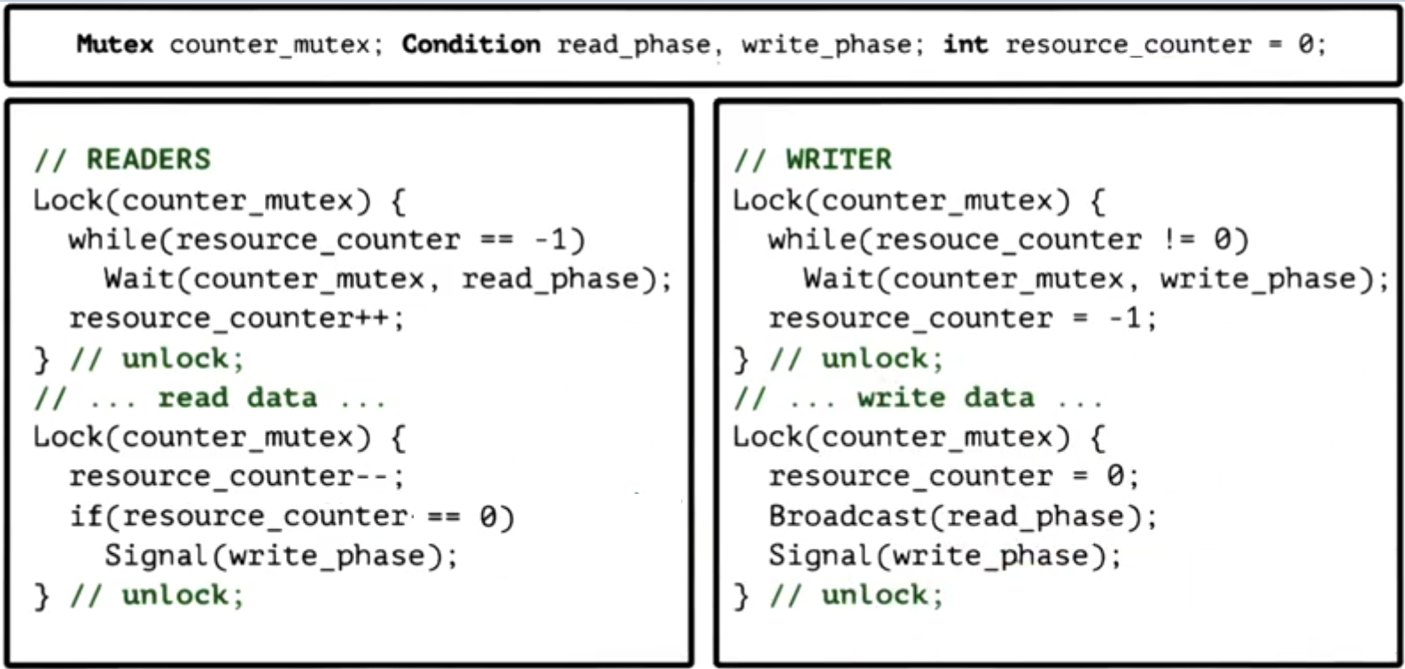

***Thread safe queue implementation:***

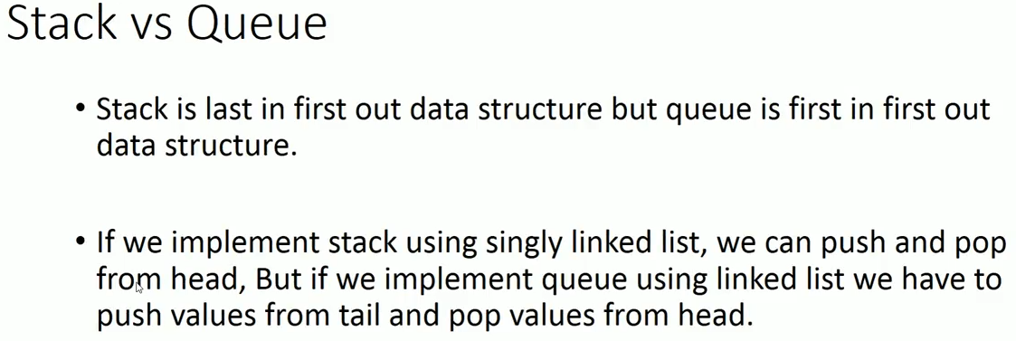

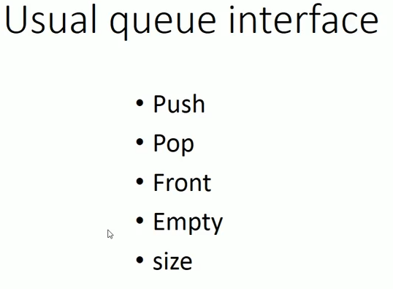

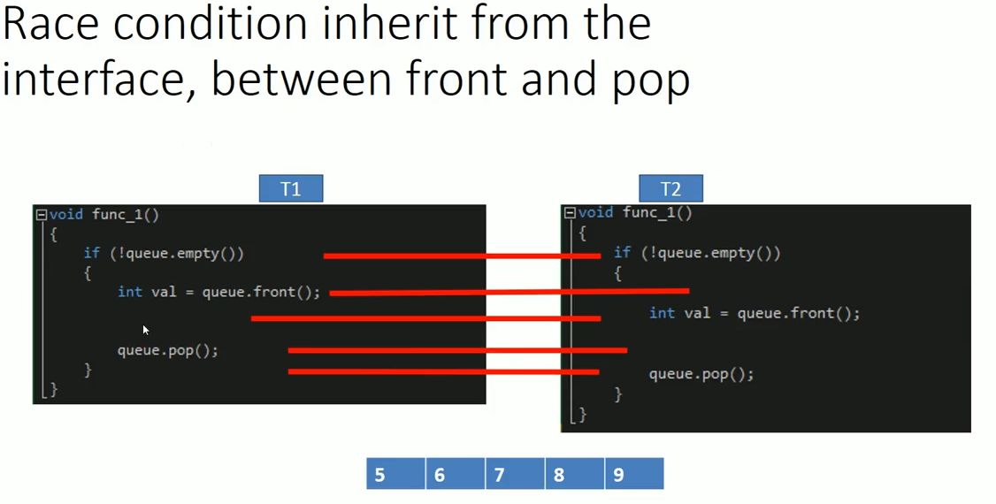

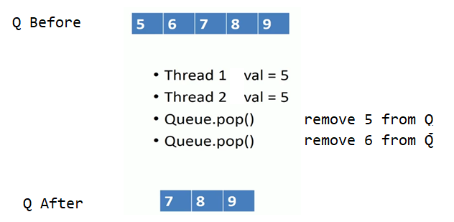

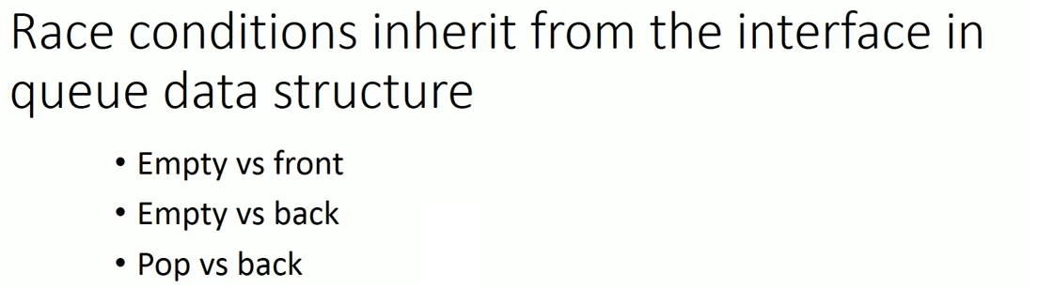

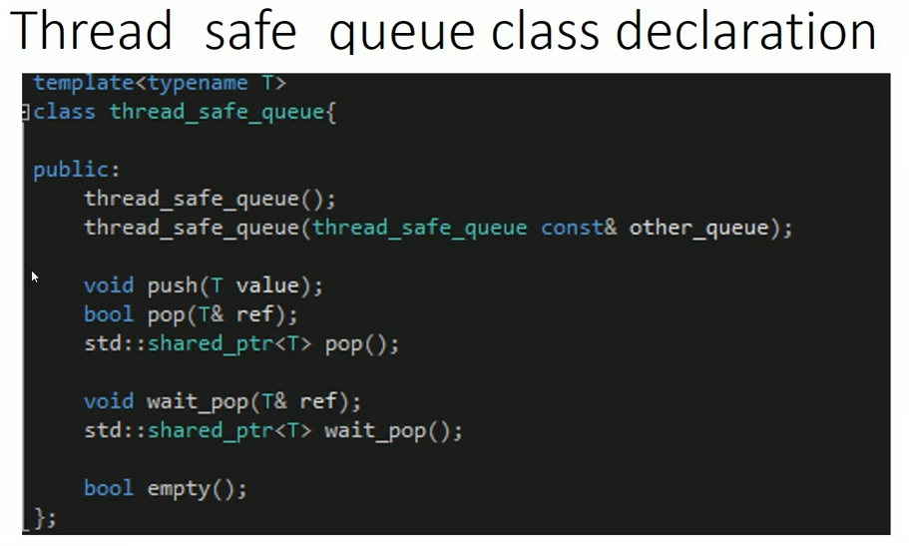

Added additional wait_pop() function which puts calling thread in waiting state if no data available in queue.

template<typename T>

class thread_safe_queue {

std::mutex m;

std::condition_variable cv;

std::queue<std::shared_ptr<T>> queue;

public:

thread_safe_queue() {}

thread_safe_queue(thread_safe_queue const& other_queue) {

std::lock_guard<std::mutex> lg(other_queue.m);

queue = other_queue.queue;

}

void push(T& value) {

std::lock_guard<std::mutex> lg(m);

queue.push(std::make_shared<T>(value));

cv.notify_one(); //useful for waited_pop() operation.

} //after push notify awaiting thread.

std::shared_ptr<T> pop() {

std::lock_guard<std::mutex> lg(m);

if (queue.empty()) { //avoiding race between pop() & empty()

return std::shared_ptr<T>();

}

else {

std::shared_ptr<T> ref(queue.front()); //store element

queue.pop(); //remove element

return ref; //return element

}

}

bool empty() {

std::lock_guard<std::mutex> lg(m);

return queue.empty();

}

std::shared_ptr<T> wait_pop() {

std::unique_lock<std::mutex> lg(m);

cv.wait(lg, [this] { //sleep until cv is not acknowledged in push()

return !queue.empty();//again for spurious wakeup, sleep thread

}); //if Q is empty & release mutex.

std::shared_ptr<T> ref(std::make_shared<T>(queue.front()));

queue.pop();

return ref;

}

size_t size() {

std::lock_guard<std::mutex> lg(m);

return queue.size();

}

bool wait_pop(T& ref) {

std::unique_lock<std::mutex> lg(m);

cv.wait(lg, [this] {return !queue.empty(); });

ref = queue.front();

queue.pop();

}

bool pop(T& ref) {

std::lock_guard<std::mutex> lg(m);

if (queue.empty()) {

return false;

}

else {

ref = queue.front().get();

queue.pop();

return true;

}

}

};

thread_safe_queue<int> queue;

**Introduction to futures and async tasks**

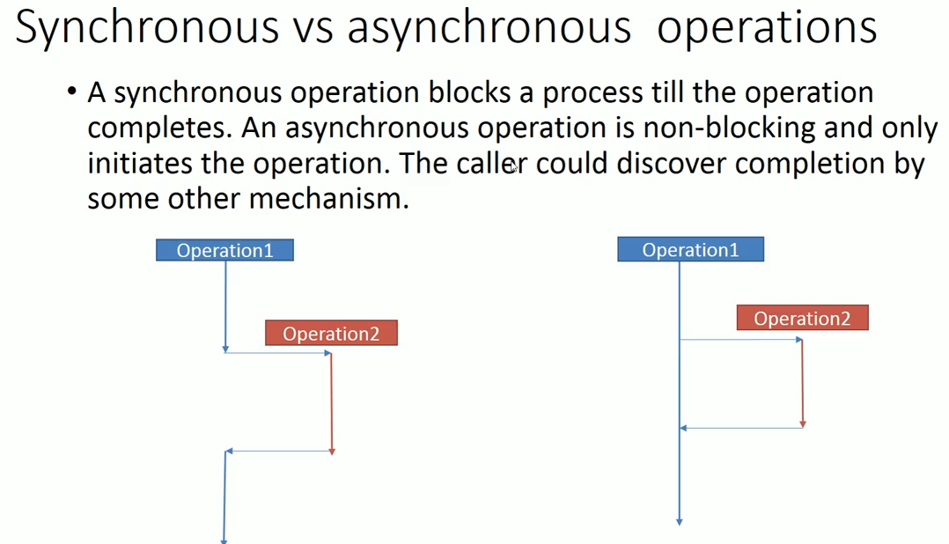

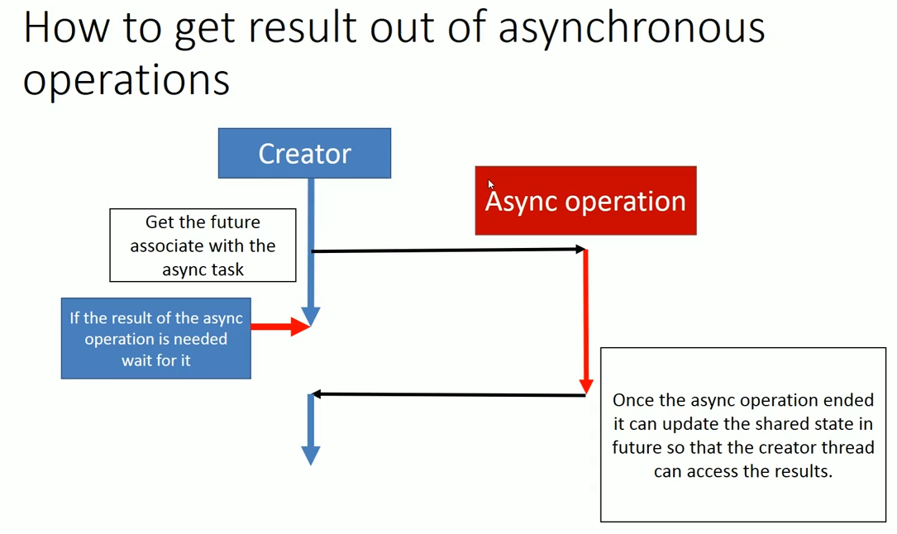

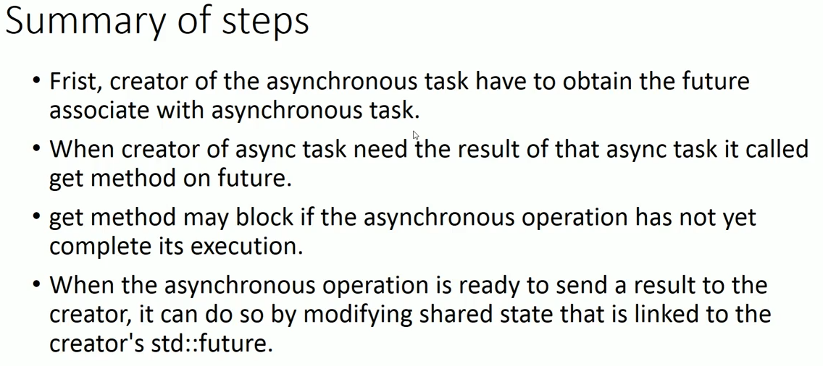

# std::future, std::promise, returning values from Thread and acync()

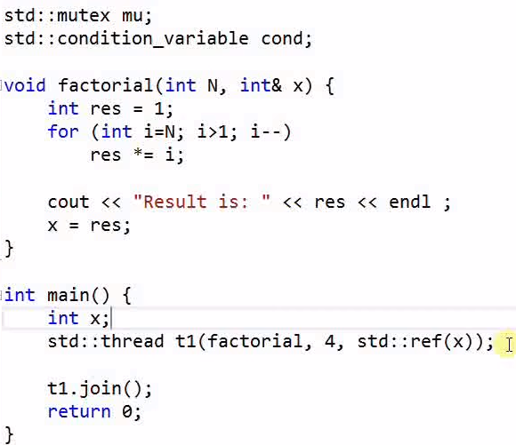

Consider the above example. All we need to, thread t1 return the calculated factorial values. Easy solution is we can pass variable as ref and fetch the value. But story is not ended here. The variable x is shared among two thread t1 and main, so we need mutex and conditional variable to well defined order of execution. Now our code will become more complicated.

**C++11 Way : Using std::future and std::promise**

**std::future** is a class template and its object stores the future value.

Actually a **std::future** object internally stores a value that will be assigned in future and it also provides a mechanism to access that value i.e. using get() member function. But if somebody tries to access this associated value of future through get() function before it is available, then get() function will block till value is not available. Get() is called by only once.

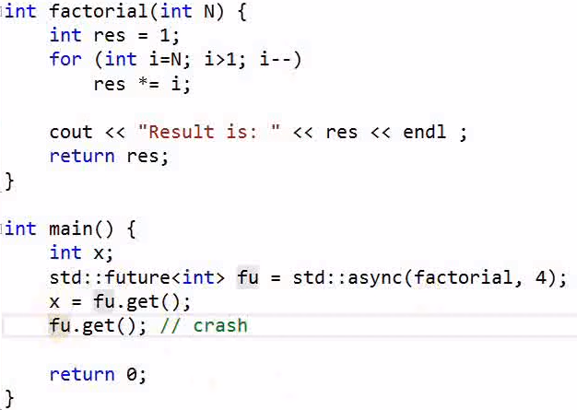

Async function launch new thread and once execution is over, it returns value which is stored into future object. But it is not always true async() method creates thread.



We can manage to create thread or not using extra parameter ***launch::deferre***. Now it we not create the thread. It defers the thread creation and when fu.get() called it simply call factorial method.



Parameter ***launch::async*** always create new thread.



Above both lines are similar, whether thread create or not decided by internal implementation and this is a default parameter.

Now we have seen how child thread return value to parent thread. But we can do in opposite manner also. For that we required ***std::promise.***

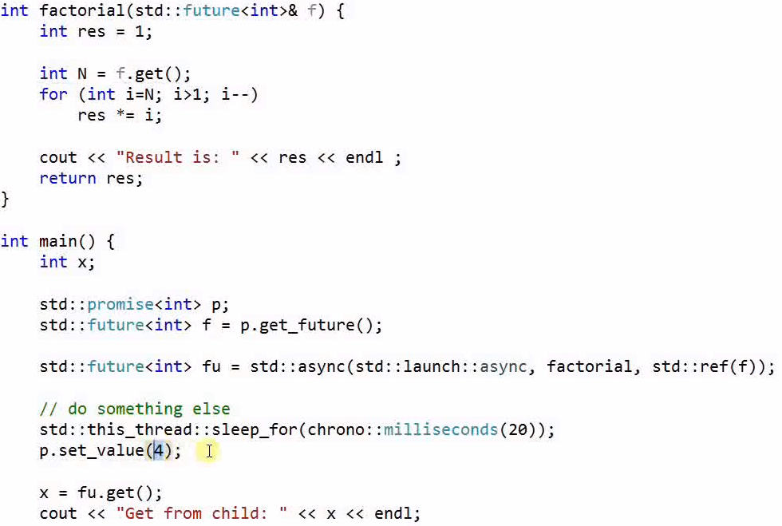

**std::promise** is also a class template and its object promises to set the value in future. Each std::promise object has an associated std::future object that will give the value once set by the std::promise object.

A **std::promise** object shares data with its associated **std::future** object.

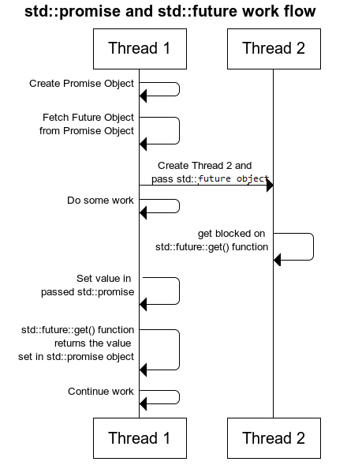

What would happen if we break the promise, means forgot to set p.setValue(4) in main thread ? In such case in child thread f.get() throws exception.

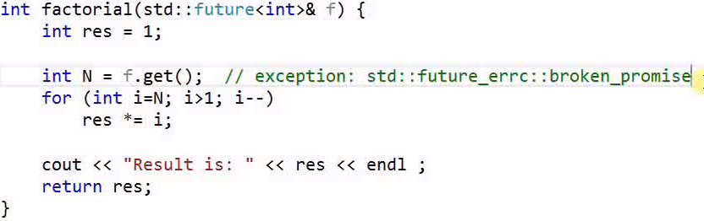

Promise and future are not copiable we can only move it.

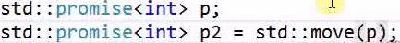

Again, suppose need to calculate factorial function 10 time or more and we are launching that many threads for it like this:

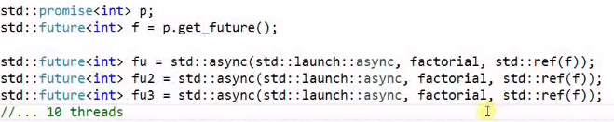

Now we can’t send same future object to different thread. Instead of that we can do this:

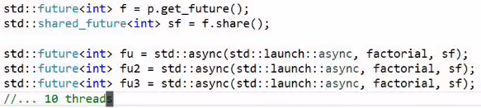



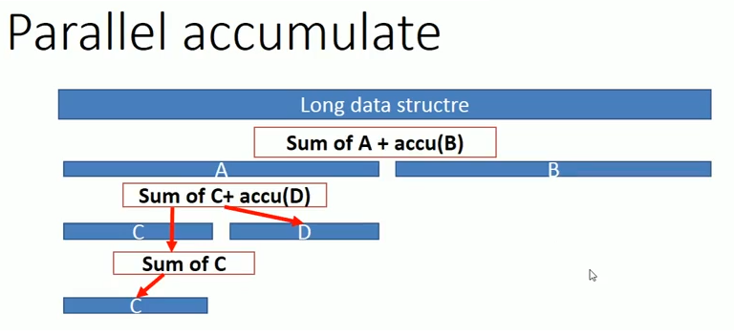

int MIN_ELEMENT_COUNT = 1000;

template<typename iterator>

int parallal_accumulate(iterator begin, iterator end){

long length = std::distance(begin, end);

//atleast runs 1000 element

if (length <= MIN_ELEMENT_COUNT) {

std::cout << std::this_thread::get_id() << std::endl;

return std::accumulate(begin, end, 0);

}

iterator mid = begin;

std::advance(mid, (length + 1) / 2);

//recursive all to parallel_accumulate

std::future<int> f1 = std::async(std::launch::deferred |

std::launch::async,parallal_accumulate<iterator>, mid, end);

auto sum = parallal_accumulate(begin, mid);

return sum + f1.get();

}

int main(){

std::vector<int> v(10000, 1);

std::cout<<"The sum is "<<parallal_accumulate(v.begin(), v.end()) << '\n';

system("pause");

return 0;

}

**Thread using callable object**

The overload of operator() in your class makes it callable.

/* async() are used in the same ways as thread(), bind() */

class TestClass {

public:

string note;

void f(int x, char c) {

note = "changed by f()";

cout << "child thread ID by f():: " << this_thread::get_id() << endl;

}

long g(double x) {

note = "changed by g()";

cout << "child thread ID by g():: " << this_thread::get_id() << endl;

return 0;

}

int operator()(int N) {

note = "changed by oerator()";

cout << "child thread ID by op():: " << this_thread::get_id() << endl;

return 0;

}

void printNote() {

cout << note.c_str() << endl;

}

};

int main() {

TestClass testObj ;

testObj.note = "Original";

cout << "main thread ID :: " << this_thread::get_id() << endl;

//just ensure child thread do first thier job.

this_thread::sleep_for(std::chrono::microseconds(1000));

//How to launch different ways of thread ?

//1. Launching thread by callable object testObj(). Note testObj is passed

by value so, any change by clild thread is not reflect in main.

std::thread t1(testObj, 6); //create copy_of_testObject and call operator().

testObj.printNote(); //Original;

//we can pass object via reference like or we can move object to child

//thread but no longer accessible to main thread like:

std::thread t1(std::ref(testObj), 6); //launch thread on testObj itself

testObj.printNote(); //changed by oerator()

std::thread t1(std::move(testObj), 6);

testObj.printNote(); //tsetObj is no longer valid for main thread.

t1.join();

//2. By using async method. Like first approach it also takes callable

object and varg as argument.

std::async(std::launch::async, testObj, 6);

testObj.printNote(); //Original since testObj passed by value.

//3. Launching a thread using lembda function

std::thread t4([](int x) {return x * x; }, 6);

t4.join();

//4. launching thread on class member function

std::thread t5(&TestClass::f, testObj, 56, 'z');

//copy_of_testObj.f(56, 'z')

testObj.printNote(); // original

t5.join();

//5. launching thread on class member function by ref

std::thread t6(&TestClass::f, &testObj, 56, 'z'); // testObj.f(56, 'z')

std::thread t6(&TestClass::f, std::ref(testObj), 56, 'z');

testObj.printNote(); // change by f()

t6.join();

//6. By using temp variable and move into thread.

std::thread(TestClass(), 6);

std::future<int> fu3 = std::async(TestClass(), 4);

// TestClass tmp; tmp is moved to async();

// create a task/thread with tmp(4);

std::future<int> fu4 = std::async(testObj, 7);

std::future<int> fu4 = std::async(std::ref(testObj), 7);

// testObj(7); Must use reference wrapper

std::future<int> fu5 = std::async(&testObj, 7); // Won't compile

std::future<void> fu1 = std::async(&TestClass::f, testObj, 56, 'z');

// A copy of testObj invokes f(56, 'z')

std::future<long> fu2 = std::async(&TestClass::g, &testObj, 5.6);

// testObj.g(5.6); testObj is passed by reference

// note: the parameter of the invocable are always passed by value, but the

// invokeable itself can be passed by ref.

getchar();

return 0;

}

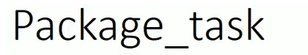

**std::packaged_task<>** is a class template and represents an asynchronous task. It encapsulates:

1. A callable entity i.e. either function, lambda function, bind() or function object.
2. Its return value or exception thrown, is stored in a shared state which can be accessed through std::future objects.

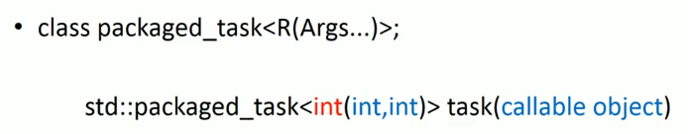

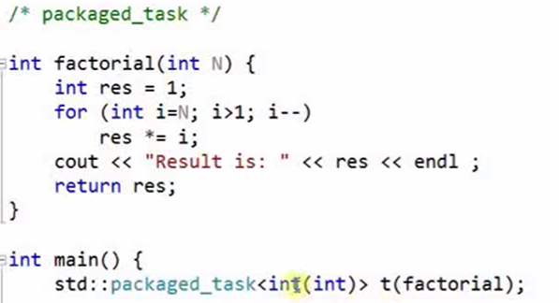

…….

t(6); // t stands for packaged_task object.

int x= t.get_feture().get();

}

As we can see it is very much like async(<args>), but async launch thread immediately rather then in packaged_task have to launch thread by calling as callable object like t(6).

In above example same can do with help of thread also:

Std::thread t1(factorial,6); //directly can pass the argument to thread.

//same can’t do with package_task.

So, how can pass parameter to packaged_task? We can use bind like below:

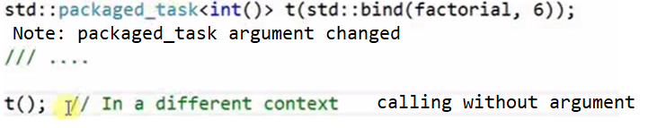

Same thing we can achieve via callable function object like:

auto t=std::bind(factorial,6); //bind return callable function object.

…..

t(); //calling functional object.

But major disadvantage in this approach, we can’t get future object from callable object. While in packaged_task we can easily get future object, which is useful in threading environment.

#### Passing packaged_task<> to a thread,

Std::packaged_task<> is movable but not copy-able, so we need to move it to thread i.e.

// Pass the packaged_task to thread to run asynchronously

std::thread th(std::move(task), "Arg");

As packaged_task was only movable and not copy-able, therefore we fetched the **std::future<>** object from it before moving it to thread. Thread will execute this task, which internally calls associated callable entity.

int add(int x, int y){

std::this_thread::sleep_for(std::chrono::milliseconds(500));

std::cout << "add function runs in :"<< std::this_thread::get_id()<<”\n”;

return x + y;

}

void task_thread(){

std::packaged_task<int(int, int)> task_1(add);

std::future<int> future_1 = task_1.get_future();

std::thread thread_1(std::move(task_1), 5, 6); //move pkg_tsk to thread

thread_1.detach(); //or can join.

std::cout << "task thread -" << future_1.get() << "\n";

}

void task_normal(){

std::packaged_task<int(int, int)> task_1(add);

std::future<int> future_1 = task_1.get_future();

task_1(7, 8);

std::cout << "task normal -" << future_1.get() << "\n";

}

int main(){

task_thread();

task_normal();

std::cout << "main thread id :" << std::this_thread::get_id() << std::endl;

system("pause");

return 0;

}

**Package_task queue example**

std::mutex mu;

std::deque<std::packaged_task<int()> > task_q;

std::condition_variable cv;

void thread_1() {

std::packaged_task<int()> t;

{

std::unique_lock<std::mutex> locker(mu); //Why unique lock?

//1. task_q has shared among thread_1 & main.

//2. because cv take unique_lock as argument not lock_guard.

while (true){

cv.wait(locker, []() {return !task_q.empty(); }); //sleep until notify. t = std::move(task_q.front()); //move only, pkg_tsk un-copyable.

task_q.pop_front(); //pop the task.

t(); //execute task.

if (task_q.empty())

break;

}

}

}

int main() {

std::thread th(thread_1); //This thread went to sleep, notify after push.

std::packaged_task<int()> task1(std::bind(factorial, 6)); //create pkg_tsk1

std::future<int> ret_fut1 = task1.get_future(); //get future for tsk1

std::packaged_task<int()> task2(bind(factorial, 9)); //create pkg_tsk2

std::future<int> ret_fut2 = task2.get_future(); //get future for tsk2 { //scope stared because accessing global variable task_q std::lock_guard<std::mutex> locker(mu);

task_q.push_back(std::move(task1)); //adding task1 to task_q

task_q.push_back(std::move(task2)); //adding task2 to task_q

}

cv.notify_one(); //Once push, notify the waiting thread.

cout << "I see: " << ret_fut1.get() << endl; //getting value from future

cout << "I see: " << ret_fut2.get() << endl; //getting value from future

th.join();

}

Communication between threads using std promise class

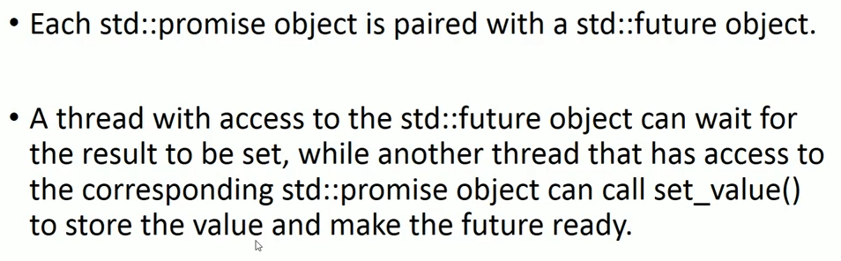

void print_int(std::future<int>& fut) {

std::cout << "waiting for value from print thread \n";

std::cout << "value: " << fut.get() << '\n'; //blocking call,

//until promise not fullfilled.

}

int main()

{

std::promise<int> prom;

std::future<int> fut = prom.get_future(); //get future form promise

std::thread print_thread(print_int, std::ref(fut));

//main thread is sleeping for 5 second. Due to this print_thread

//is also went to waiting state. fut.get() block its execution

//until prom.set_value(10) not completed.

std::this_thread::sleep_for(std::chrono::milliseconds(5000));

std::cout << "setting the value in main thread \n";

prom.set_value(10); //now only print_thread continues its execution

print_thread.join(); //also can join the thread.

//Just think what would happened if we set promise

//after joining print_thread? -- Deadlock

system("pause");

return 0;

}

Retrieving exception using std::futures & promise

void throw_exception(){

throw std::invalid_argument("input cannot be negative");

}

void calculate_squre_root(std::promise<int>& prom){

int x=1;

std::cout << "Please, enter an integer value: ";

try {

std::cin >> x;

if (x < 0){

throw_exception(); //throwing exception.

}

//if input is valid, fullfill the promise.

prom.set_value(std::sqrt(x));

}

catch (std::exception&){ //otherwise set promise with exception.

prom.set_exception(std::current_exception());

}

}

void print_result(std::future<int>& fut) {

try{

int x = fut.get();

std::cout << "value: " << x << '\n';

}catch (std::exception& e) {

std::cout << "[exception caught: " << e.what() << "]\n";

}

}

int main(){

//In this example we are going to calculate squre_root of given

//number & throw exception if given number < 0.

std::promise<int> prom; //create promise object

std::future<int> fut = prom.get_future(); //get future form promise

//printing_thread is responsible for print result (either valid or

//exception). So, future is passed as argument with this thread. it has

//blocking call fu.get() and wait until promise is not full-filled by

//calculation_thread.

std::thread printing_thread(print_result, std::ref(fut));

//calculation_thread is responsible for obtaining input, validating input,

//throw exception if input invalid & calculate the squre_root if everything

//fine.

std::thread calculation_thread(calculate_squre_root, std::ref(prom));

printing_thread.join();

calculation_thread.join();

system("pause");

return 0;

}